**Recosense NGINX Deployment Workflow**

1. Create A subdomain (A record) entry on Linode, Add the subdomain name on host column and IP Address of the server you want to deploy the application on.

Screenshot below for reference:

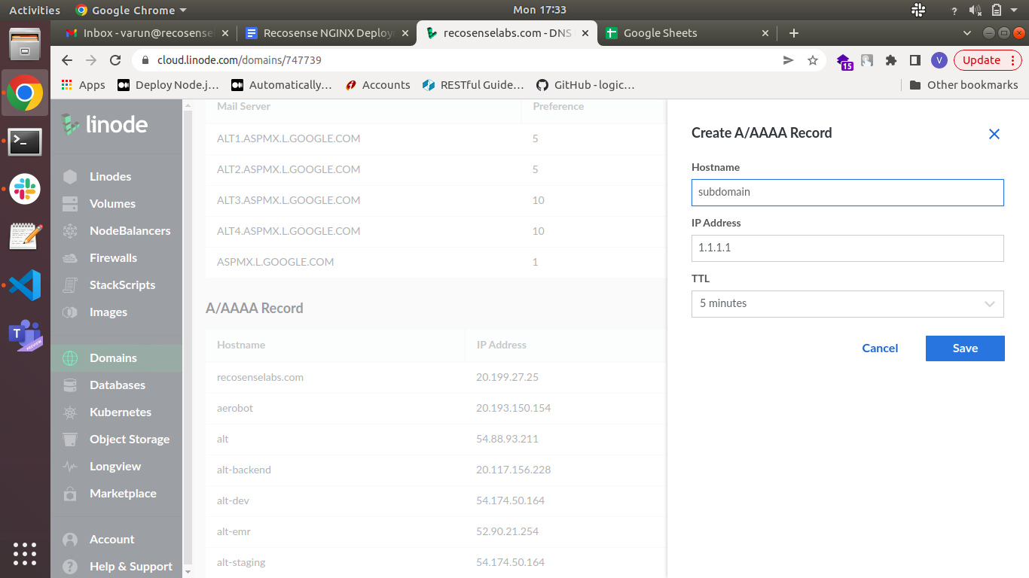

1. Login to the server that the subdomain was configured to using the IP

“ ssh username@ipaddress” or ssh -i keyfile.pem username@ipaddress”

1. Make sure Nginx and Certbot are installed on the server.

Nginx installation: <https://www.digitalocean.com/community/tutorials/how-to-install-nginx-on-ubuntu-18-04>

Certbot Installation:

https://certbot.eff.org/instructions?ws=nginx&os=ubuntufocal

1. Creating nginx conf file for the domain in the path /etc/nginx/sites-available/ as yourdomain.conf.

**continue-next-page……**.

1. Below is a template file link for a nginx conf file for both frontend and backend for root / path or any other other specific path.

“<https://docs.google.com/document/d/1cWGvuuJ6PmOhM7glQF0ycJE541OcWzt1d-4X90nVGRw/edit?usp=sharing>”

1. Create symbolic link between sites-available and sites-enabled folder using the below command

“sudo ln -s /etc/nginx/sites-avalable/filename.conf /etc/nginx/sites-enabled/”

1. Run the below command to create ssl certificate using certbot, it will automatically create and add the certificate to the conf file.

“sudo certbot nginx”

The above command will give a list of domains available on the server, choose the domain number you want to configure the ssl certificate for and press enter. Accept all the prompts as yes and press enter. You should be able to see the message

Deployed Successfully to verify that the ssl certificate was created successfully.

1. Run the below command to check that nginx file is correct without errors

“sudo nginx -t”

1. If above command gives out as no error message, reload nginx on the server with the below command

“sudo systemctl reload nginx”

1. If all the above steps was complete successfully go to your https secure website.

<https://your-domain/> or <https://your-domain/path/>